**Homework 1 Writeup**

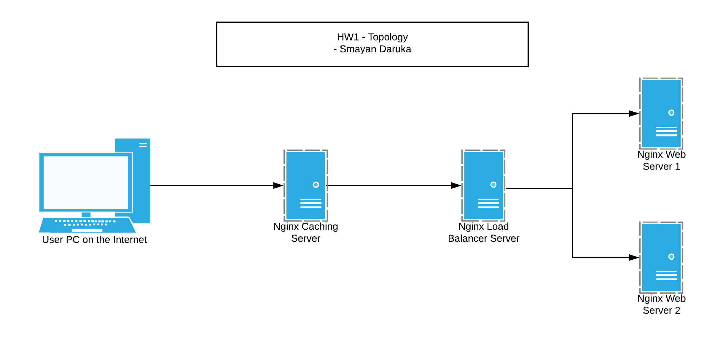

The above shows my topology of choice for this homework. On the far left, there is a user PC on the internet that is trying to access the webpage. Ideally speaking, the caching server comes next since it has the ability to serve webpages to the user without actually having to go the webservers itself. In the scenario that the caching server doesn’t have webpage, the user then hits the load balancer which directs traffic based on circumstances to either of the two webservers. I chose this topology since it made the most sense to me from a technological perspective and keeping in mind resource utilization. Keeping in mind the cost factor and the resource utilization, the caching server would heavily reduce traffic to the webservers and serve as a first point of contact for the outside world. Following that is the load balancer to ensure that no one webserver is overloaded with requests and that there is no network congestion.

Upon validating my HTML source code, I got a warning indicating missing language tags which I added as well. Other than that, the source serves a really simple page with a single line of content. I chose to use Nginx for all the servers including the cache and the load balancer as well as the two web servers. I personally have used Nginx a couple of times in the past and know my way with it, so it was definitely my first choice. From a deployment perspective, I can’t say a lot since I don’t have too much of an experience with various web technologies, but from what I’ve heard, Apache is pretty easy to deploy and Nginx too.

These various technologies – caching server, and load balancer are really helpful in reducing load to web servers. Not all companies have a lot of computing power and there can be financial constraints that lead to looking for alternatives and reducing cost. These technologies aren’t that useful for a webpage like the one I created for this homework since the page only has a single line of content so there isn’t going to be that much of a load issue.